Academic Year (1438-1439H)
Curriculum vitae
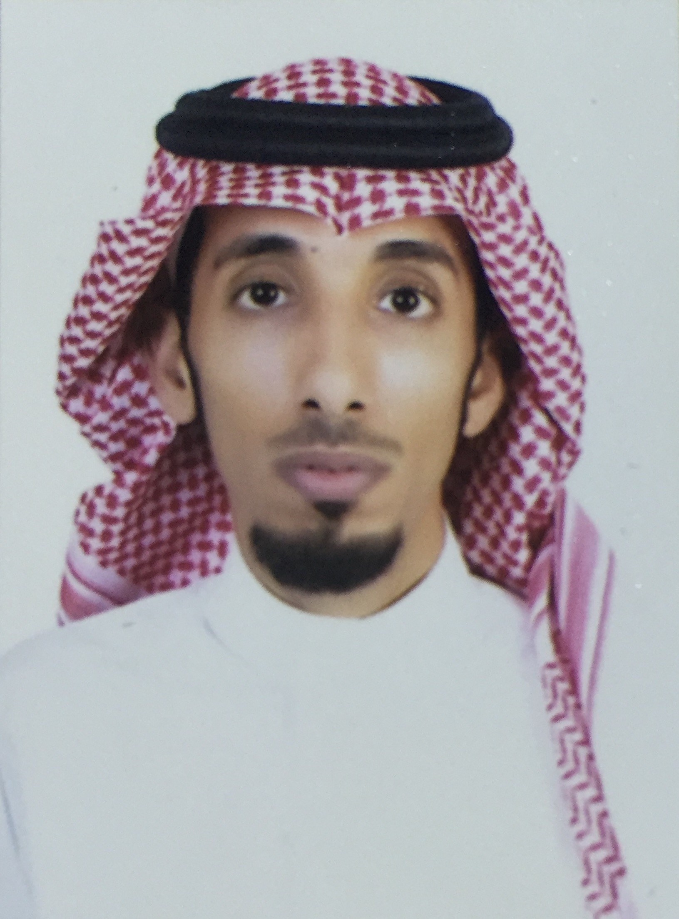

General Information
Full Name |  | DR. ALSAIARI. SALAIMAN AYED
Address |  | Najran
Mobile Phone Number |  | 966566654269
E-mail(s) |  | s-alsaiary2@hotmail.com
Nationality |  | saudi
Date of birth |  | 22 march 1988
Marital Status |  | Married
Mother tongue |  | Arabic
Other Languages |  | English
Current position : Teaching assistant

Qualifications:
  - Arab Board in Dermatology in 16/11/2017,from the Arab Board of health specialization, Damascus, Syria.

  - European board in dermatology and venereology in 04/08/2017 from the European union of medical specialities-EBDV, Germany .

  - Training completion certificate in dermatology from 01/10/2012 to 30/09/2016, from the saudi commission for health specialties, makkah, saudi Arabia.

  - Bachelor of Medicine & Surgery in June 2011 from King Khalid University, College of Medicine, Abha, Saudi Arabia, Grade: “Very Good” G.P.A. (4.12 out of 5).

Work experience:

Occupation or position held | Main activities and responsibilities (academic & administrative) | Name and address of employer | Dates
Senior Registrar Dermatologist | - Member of the najran university hospital executive committee  - OPD director  - Head of Infection Control and public health department | Najran University Hospital, Najran, Saudi, Arabia, | 1438- to present.
Teaching assistant | - Supervisor of GIT 7 block (GIT 362)  - Member of interns and graduates committee | Internal medicine department, College of Medicine, Najran University Hospital, Najran, Saudi, Arabia | 1433- to present.

Education and training:

Title of qualification awarded | Principal subjects / occupational skills covered | Name and type of organisation providing education and training | Dates
Arab Board in Dermatology |  | Arab Board of health specialization, Damascus, Syria. | 16/11/2017
European board in dermatology and venereology |  | European union of medical specialities-EBDV, Germany . | 04/08/2017
Training completion certificate in dermatology |  | saudi commission for health specialties, makkah, saudi Arabia. | from 01/10/2012 to 30/09/2016

Continuous Education Courses:

-
-
-

Personal skills, hobbies and competences:

-
-
-

