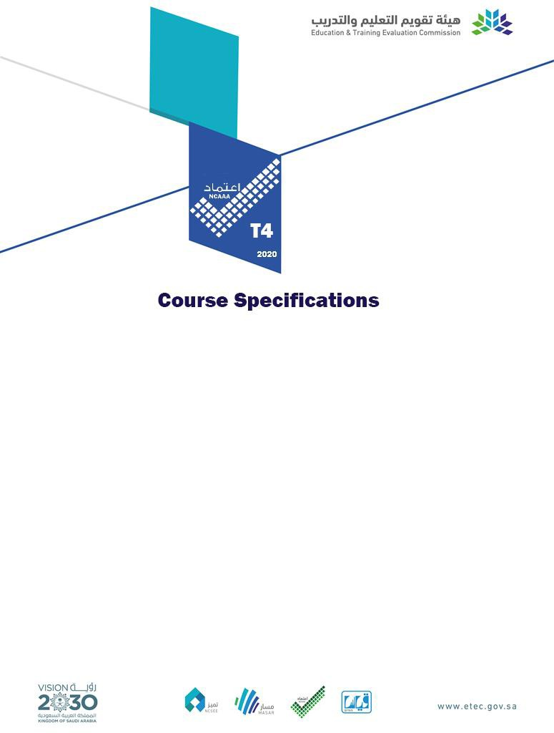

Course Title: | Man and His Internal Environment
Course Code: | 243MIE-5
Program: | Bachelor of Medicine and Bachelor of Surgery (MBBS)
Department: | NA
College: | Medicine
Institution: | Najran University

- Course Identification

1. Credit hours:
5 (4+1)
2. Course type
a. | University | College |  | Department |  |  |  |  |  | Others | √ | (Program)
b. | Required | √ | Elective
3. Level/year at which this course is offered: |  |  |  |  |  |  |  | Year 2 - Semester-1 (level 4)
4. Pre-requisites for this course (if any):
None
5. Co-requisites for this course (if any):
None

- Mode of Instruction (mark all that apply)
No | Mode of Instruction | Contact Hours | Percentage
1 | Traditional classroom
2 | Blended | 60 | 65.2%
3 | E-learning
4 | Distance learning
5 | Other | 32 | 34.8%

- Contact Hours (based on academic semester)
No | Activity | Contact Hours
1 | Lecture | 60
2 | Laboratory/Dissection Room (DR) | 26
3 | Tutorial
4 | Others (specify)
 | Skill lab | 6
 | Total | 92

- Course Objectives
1. Course Description
This course is delivered to the medical students at level four/2ndyear. The course provides an integrated basic knowledge of human physiology and biochemistry in the context of the internal environment and homeostasis. The physiology part primarily focuses on body fluids compartments, the concept of the internal environment, and maintaining its constancy (i.e., homeostasis), body temperature regulation as an example, and the autonomic nervous system as a neural system for homeostasis. The biochemistry part concentrates on the intracellular environment, as well as the chemical conditions of the internal environment, e.g. pH. Basic structure of atoms, classification and reactions of organic compounds, stereochemistry, fluids pH, and the structure, functions and interactions of bio and macromolecules in living matter will be covered. In addition, the role of vitamins and minerals in biochemical processes will be highlighted. The basic physiology and biochemistry facts given in this course will enable the students to build on and integrate knowledge in the later years of study.
2. Course Main Objective
By the end of this course, the students are expected to:
- Recognize the concepts of the internal environments and the maintenance of its constancy (i.e., homeostasis).
- Describe the feedback mechanism and their role in homeostasis.
- Discuss the regulation of body temperature as an example of homeostasis.
- Recognize the role of biochemistry inside cells and in the internal environment.

- Course Content
No | List of Topics | Contact  Hours
1. | Composition of human body (Phys-L) | 1
2. | Body fluids compartments-1 (Phys-L) | 1
3. | Body fluids compartments-2 (Phys-L) | 1
4. | Electrolyte composition of body fluids-1 (Phys-L) | 1
5. | Electrolyte composition of body fluids-2 (Phys-L) | 1
6. | Disturbances of volume and concentration of body fluids-1(Phys-L) | 1
7. | Disturbances of volume and concentration of body fluids-2(Phys-L) | 1
8. | Concept of internal environment and homeostasis (Phys-L) | 1
9. | Feedback mechanisms (Phys-L) | 1
10. | Cell organelles and their functions-1 (Phys-L) | 1
11. | Cell organelles and their functions-2 (Phys-L) | 1
12. | Transport across cell membrane: passive transport mechanisms (Phys-L) | 1
13. | Transport across cell membrane: Active transport mechanisms (Phys-L) | 1
14. | Capillary fluid exchange and edema (Phys-L) | 1
15. | Intercellular communication (Phys-L) | 1
16. | Chemical messengers and signal transduction (Phys-L) | 1
17. | Body temperature (core temperature, heat gain & loss, factors affecting body  temperature) (Phys-L) | 1

18. | Regulation of body temperature and mechanism of fever-1 (Phys-L) | 1
19. | Regulation of body temperature and mechanism of fever-2 (Phys-L) | 1
20. | Disorders of body temperature regulation: hypothermia, heat stroke and heat  exhaustion (Phys-L) | 1
21. | Introduction to electrophysiology: Resting membrane potential & Action  potential (Phys-L) | 1
22. | Organization of the nervous system (central and peripheral); differences between  somatic and autonomic nervous systems (Phys-L) | 1
23. | Organization of the autonomic nervous system (sympathetic & parasympathetic)  and autonomic ganglia: types and functions (Phys-L) | 1
24. | Origin and distribution of the sympathetic nervous system (Phys-L) | 1
25. | Origin and distribution of the parasympathetic nervous system (Phys-L) | 1
26. | Neurotransmitters-1: Acetylcholine: synthesis, release, and inactivation (Phys-L) | 1
27. | Neurotransmitters-2: Catecholamines: synthesis, release, and inactivation (Phys-  L) | 1
28. | Autonomic receptors-1: Cholinergic receptors (nicotinic & muscarinic) and their  signal transduction (Phys-L) | 1
29. | Autonomic receptors-2: Adrenergic receptors (alpha and beta) and their signal  transduction (Phys-L) | 1
30. | Autonomic effects on different body organs; autonomic disorders Horner’s  Syndrome and pesticides poisoning (Phys-L) | 1
31. | Units and concentrations (mole, osmoles, molecular weight, equivalents) (Phys-  Lab) | 2
32. | Measurement of osmolality of solutions and demonstration of osmosis (Phys-  Lab) | 2
33. | Types of fluids and the effects of their infusion on body fluid compartments  (Phys-lab) | 2
34. | Homeostasis: Effects of exercise on pulse, blood pressure and body temperature  (Phys-Skill lab). | 3
35. | Measurement of body temperature (Phys-Skill lab) | 3
36. | Demonstration of parasympathomimetic and parasympatholytic drugs on  experimental animals (Phys-lab) | 2
37. | Demonstration of sympathomimetic and sympatholytic drugs on experimental  animals (Phys-lab) | 2
38. | An introduction to medical biochemistry(Bio-L) | 2
39. | The biological significance of pH in human body fluids(Bio-L) | 2
40. | Simple carbohydrates (Bio-L) | 2
41. | Complex carbohydrates-1(Bio-L) | 2
42. | Complex carbohydrates-2 (Bio-L) | 2
43. | Biochemistry of lipids part 1(Bio-L) | 2
44. | Biochemistry of lipids part 2(Bio-L) | 2
45. | Amino acids: structure, classification and function(Bio-L) | 2
46. | Protein structure, organization, function(Bio-L) | 2
47. | Enzymes: kinetics and mechanism of action(Bio-L) | 2

48. | Regulation of enzymatic activities(Bio-L) | 2
49. | Nucleotides biochemistry(Bio-L) | 2
50. | Polymeric organization of the genetic material (Bio-L) | 2
51. | Fat soluble vitamins (Bio-L) | 2
52. | Water-soluble vitamins (Bio-L) | 2
53. | Measurement of solutions pH (Bio-Lab) | 2
54. | Detection of carbohydrates-1 (Bio-Lab) | 2
55. | Detection of carbohydrates-2 (Bio-Lab) | 2
56. | Detection of carbohydrates-3 (Bio-Lab) | 2
57. | Differentiation between saturated and unsaturated fatty acids (Bio-Lab) | 2
58. | Detection of amino acids and proteins-1 (Bio-Lab) | 2
59. | Detection of amino acids and proteins-2 (Bio-Lab) | 2
60. | Enzymes kinetic (Bio-Lab) | 2
Total |  | 92

L=Lecture, Phys=Physiology, Ana=Anatomy, His=Histology, Bio=Biochemistry

- Assessment Tasks for Students

# | Assessment task* | Week Due | Percentage of Total Assessment Score
1 | Midblock (written test - MCQs & SAQs) | 3rd | 30 %
2 | Rubric-based Logbook assessment | 5th | 10 %
3 | End of course Exam:  Theory (40%) - (written test - MCQs) Practical (20%) – OSPE | 5th | 60 %
 | Total |  | 100 %
*Assessment task (i.e., written test, oral test, oral presentation, group project, essay, etc.)

- Learning Resources and Facilities
  - Learning Resources
Required Textbooks | - Physiology:  - Guyton and Hall Textbook of Medical Physiology, 14th Edition(2021) by John E. Hall, Arthur C Guyton,Elsevier ISBN: 978-0-323-59712-8.  - Ganong's Review of Medical Physiology (LANGE), 26th Edition (2019) by Kim E. Barrett (Author), Susan M.Barman (Author), Heddwen Brooks (Author), JasonYuan (Author), McGraw-Hill's ISBN 978-1-26- 012241-1  - Biochemistry:  - Harper's Illustrated Biochemistry Thirty-First Edition 31st (2021) by Victor Rodwell (Author), David Bender (Author), Kathleen Botham (Author), Peter Kennelly (Author), P. Anthony Weil (Author)  - Lippincott Illustrated Reviews: Biochemistry (Lippincott Illustrated Reviews Series) Eighth Edition (2021), North American by Emine E. Abali (Author), Susan D. Cline (Author), David S. Franklin (Author), Dr. Susan M. Viselli Ph.D. (Author).

Essential References Materials | - Biochemistry and Molecular Biology 6E 6th Edition (2018) by Alison Snape (Author), DespoPapachristodoulou (Author), William H. Elliott (Author), Daphne C. Elliott (Author).
Electronic Materials | - Saudi Digital Library (https://sdl.edu.sa).  - http://www.adameducation.com/interactive-physiology
Other Learning Materials | 1. Biochemistry Ninth Edition (2019) by Jeremy M. Berg (Author), John L. Tymoczko (Author), Gregory J. Gatto Jr. (Author), LubertStryer (Author)
  - Facilities Required
Item | Resources
Accommodation  (Classrooms, laboratories, demonstration rooms/labs, etc.) | - Lecture room suitable for enrolled number of students.  - Laboratory (Dissection Room-DR, Histology, Physiology, Biochemistry, and clinical skills) suitable for the enrolled number of students and equipped  with required teaching instruments
Technology Resources  (AV, data show, Smart Board, software, etc.) | 3. Computers and audiovisual aids in the lecture room and laboratories.
Other Resources  (Specify, e.g. if specific laboratory  equipment is required, list requirements or attach a list) | Library supplied with reference, textbooks, and electronic resources.

- Specification Approval Data
Council / Committee | Council of Medical Education Department
Reference No. | 202210-214-005557-011566
Date | 14/03/1444 H

