Academic Year (1438-1439H)
Curriculum vitae
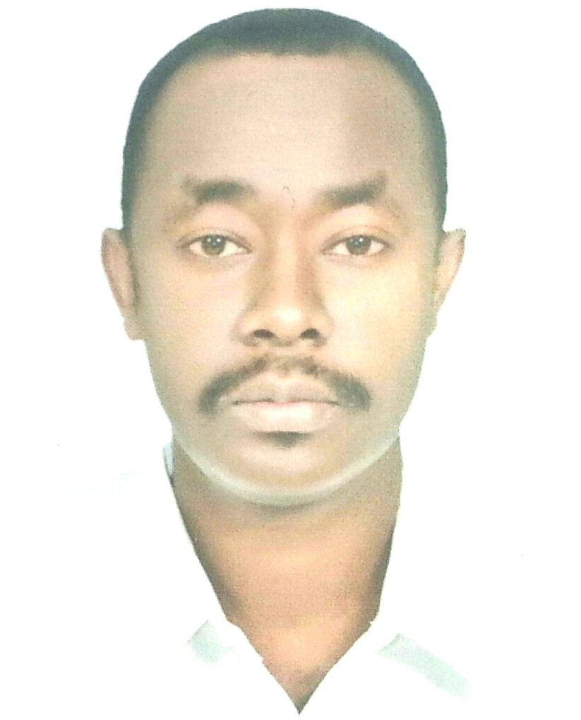
General Information
Full Name |  | AHMED HASSAN MOHAMMED ABDELRAHEEM
Address |  | NAJRAN UNIVERSITY FACULTY OF MEDICINE
Mobile Phone Number |  | 00966565993679
E-mail(s) |  | AHMD2666@YAHOO.COM
Nationality |  | SUDANESE
Date of birth |  | 22/04/2018
Marital Status |  | MARREID
Mother tongue |  | ARABIC
Other Languages |  | ENGLISH
Current position : ASSISTANT PROFFESSOR

Qualifications: MD INTERNAL MEDICINE

Work experience:

Occupation or position held | Main activities and responsibilities (academic & administrative) | Name and address of employer | Dates
ASSITANT PROFESSOR | TEACHING CLINICAL INTAERNAL MEDICINE | GADARIF UNIVERSITY | 2012-2013
ASSISTANT PROFESSOR | TEACHING CLINICAL INTAERNAL MEDICINE  NAJRAN UNIVERSITY HOSPITAL  QUALITY CONTROL WORK  OTHER HEALTH COLLAGES NURSING AND DENTAL COLLAGE  RESEARCH | NAJRAN UNIVERSITY | 2013 TILL NOW

Education and training:

Title of qualification awarded | Principal subjects / occupational skills covered | Name and type of organisation providing education and training | Dates
MD | INTARNAL MEDICINE | SUDAN MEDICAL SPECIALIZATION BOARD | 2012

Continuous Education Courses:

- Basic course in system and Methods in university teaching organized by ATPDC (advance training and performance development center university of Khartoum 3/2012)
- Teaching on the Run may/2014

Personal skills, hobbies and competences:

English language – reading- computer and internet browsing
Analytical skills and the ability to deal effectively with all levels of an organization

-

